WashU Student ID:
Proposed Title:
Academic Division:
Keywords: Format; like; this.

Abstract (~250-300 words maximum):

Additional Comments (only if needed, otherwise may remove):

Introduction
Lorem ipsum odor amet, consectetuer adipiscing elit. Senectus sollicitudin justo sit; id aliquet natoque. Semper nostra libero cubilia dui natoque dignissim vestibulum. Aptent viverra neque etiam volutpat accumsan iaculis dis; mollis orci. Fames senectus turpis taciti venenatis potenti erat. Euismod nascetur mattis pellentesque rhoncus feugiat commodo sapien felis. Massa neque sit ullamcorper egestas penatibus quisque ullamcorper lacus nisi. Ornare ipsum hac odio bibendum faucibus penatibus commodo netus? Sem nascetur gravida sit vehicula nisl and here is a citation [1].

Methods, etc.
In this study, a capybara (Fig 1) was used. Lorem ipsum odor amet…
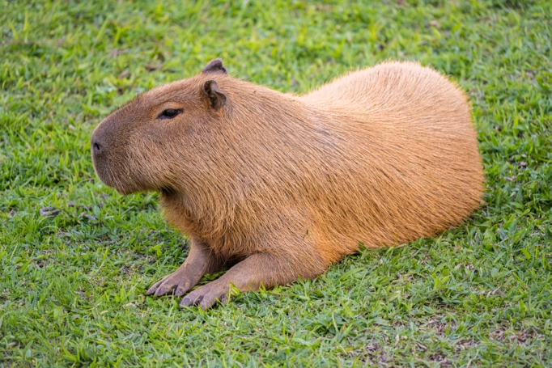

Figure 1. This is a picture of a capybara. A caption is added to the image thru select image > references > insert caption.

References
[1] Lowry, O., Rosebrough, N., Farr, A., and Randall, R. (1951). Protein measurement with the Folin phenol reagent. Journal of Biological Chemistry, 193(1), 265-275.

References should follow the above numeric (i.e. [1]) citation style. You may use the citation style which is most appropriate for your field of work. Generally, you may use APA for NSME and Social Sciences articles, or MLA for Humanities.

