Supplementary Table 1. Primer sequences used for RT-qPCR.
Target Gene | Primer Pair 5’ -> 3’
Fgfbp1 | F:ACGGAGCCAAACAGGGTCAAAG / R:GGTCTTCCTCTGGTTGAGCACA
Mex3a | F:AGAGCCTCACGCAACAAGTCTG / R:CTGGATGCGTTTGATGGTCGCT
Gapdh | F:TGGCCTTCCGTGTTCCTAC / R:TGCGACTTCAACAGCAACTC
Cyp24a1 | F:GCTCCTTCAAAAGGACACAGAGG / R:CGCTTGCCACACTTTGGTGTTG
Lgr5 | F:AGAGCCTGATACCATCTGCAAAC / R:TGAAGGTCGTCCACACTGTTGC
Hopx | F:GCCCCAGTGTAAAGAAATGGT / R:GTGACGGATCTGCACTCTGA
Atoh1 | F:CTGGTAAGGAGAAGCGGCTGTG / R:CCATTCACCTGTTTGCTGGAAGG
Msi1 | F:GTTCATCGGAGGACTCAGTTGG / R:CTGGTCCATGAAAGTGACGAAGC

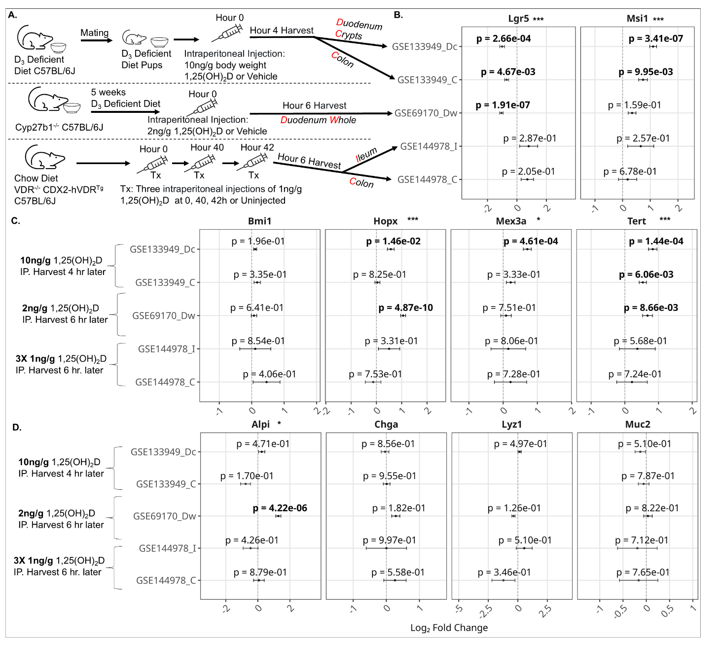
Supplementary Figure 1. Meta-analysis of existing datasets. A). In GSE133949, C57BL/6J mice under a vitamin D-deficient diet mate to produce pups who are also fed a vitamin D-deficient diet. The pups are injected IP with 10 ng/g body weight of 1,25(OH)₂D or Vehicle. Four hours later, duodenum crypts and colons are harvested for RNA-seq. In GSE69170, Cyp27b1^{-/-} C57BL/6J mice are fed a vitamin D-deficient diet for 5 weeks, then injected IP with 2 ng/g 1,25(OH)₂D or Vehicle. Six hours later, whole duodenum was harvested. In GSE144978, mice were fed standard chow diet and were either left uninjected or injected IP 3 times at hours 0, 40, 42 with 1 ng/g 1,25(OH)₂D. Six hours later, ileum and colon were harvested. B). Actively cycling stem cell markers. C). Reserve stem cell markers. D). Mature epithelial cell markers, Apli (Enterocytes), Chga (Enteroendocrine), Lyz1 (Paneth), Muc2 (Goblet). Error bars represent ± 2x SEM. * p < 0.05, ** p < 0.01, *** p < 0.001. Significant differential expression in individual studies is bolded.

